Lab Work Part 3 - Robot Manipulators

Task 1 - Introduction to Kinova Gen3 Lite Robot

Part 1 - The build
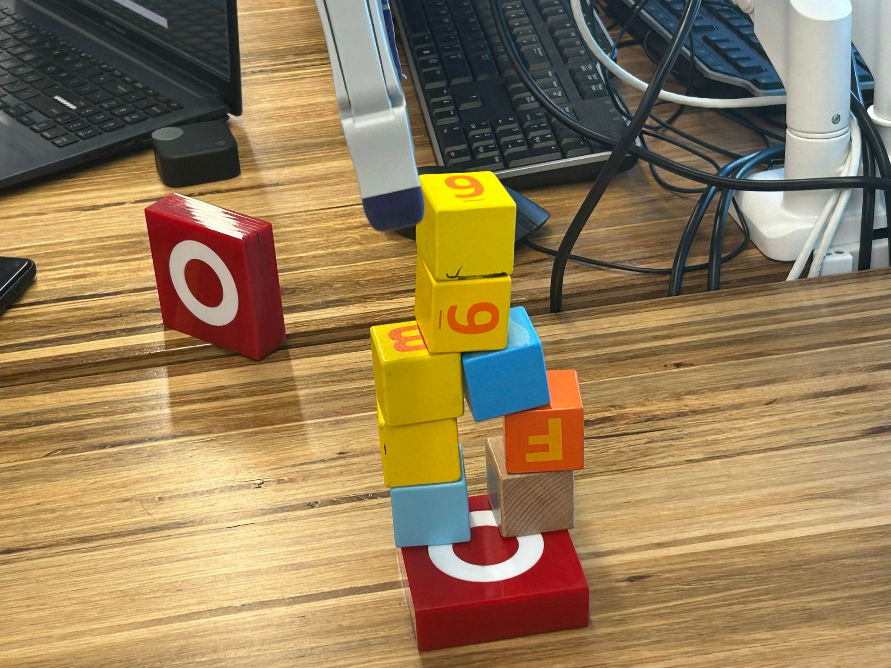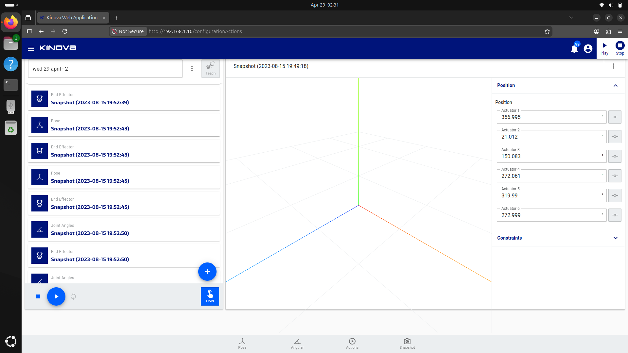

Part 2 - The simulation
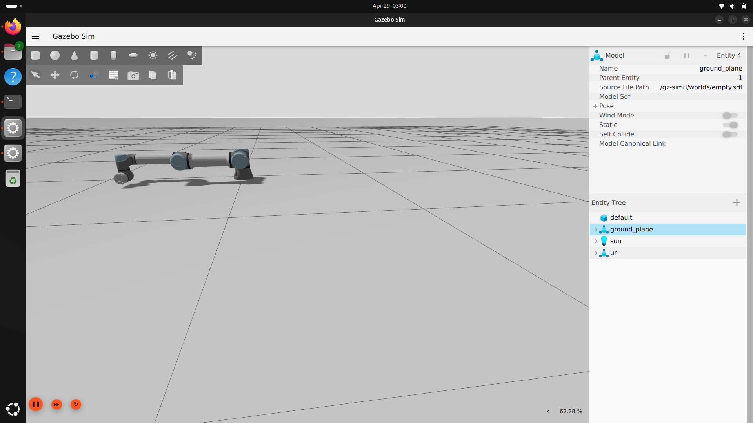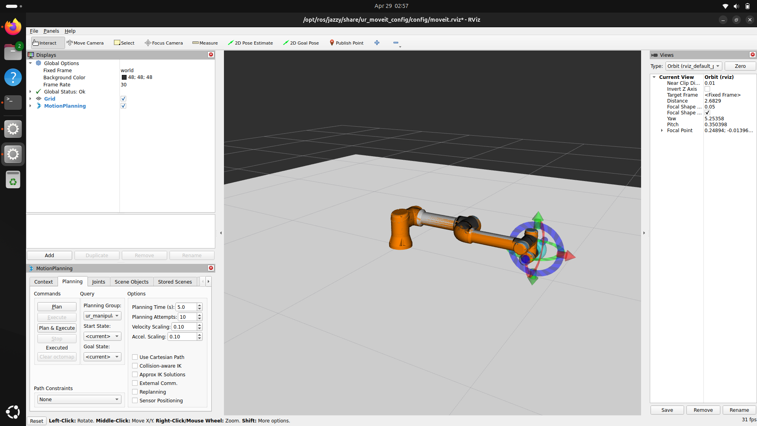

Task 2 - Simple Two-Link Manipulator
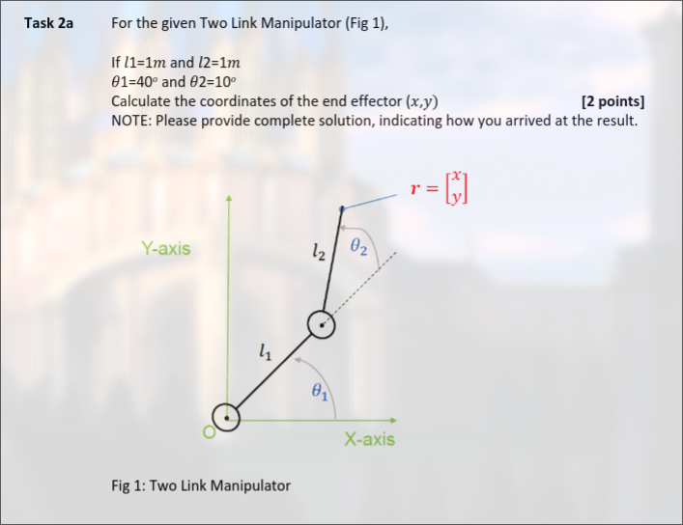

Part 1 - Manual Working Out
Given the Two-Link Manipulator in Fig 1, with the following parameters:
- 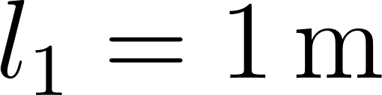
- 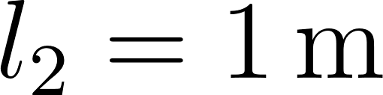
- 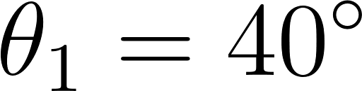
- 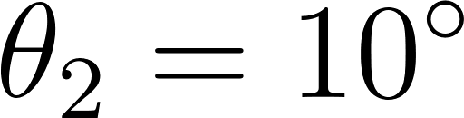

The coordinates 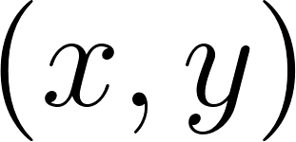 of the end effector are determined by the sum of the link vectors. Note that the angle of the second link relative to the x-axis is 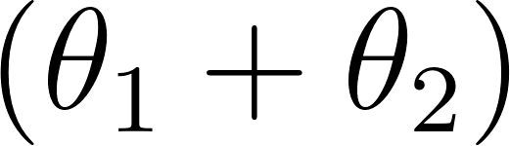.

Substitute the given values into the equations:
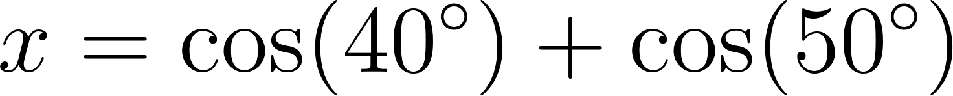
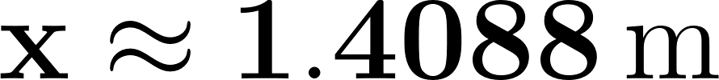

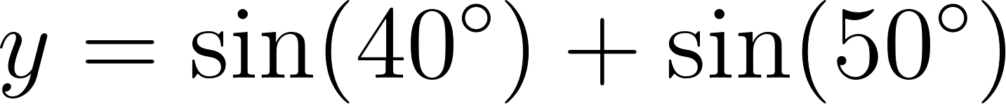
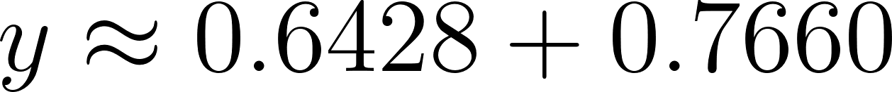
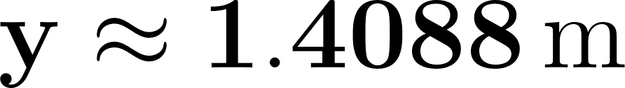

The coordinates of the end effector 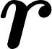 are:

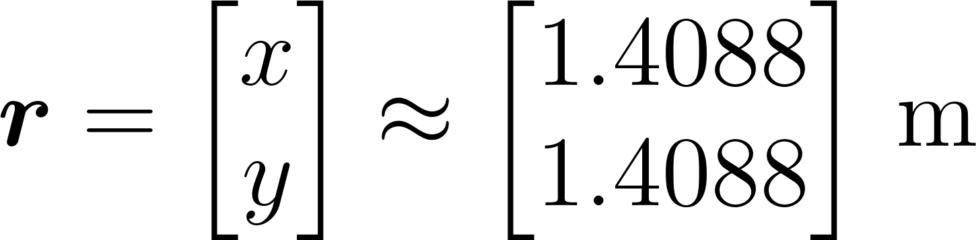

Part B - Pseudo Code
Write a suitable algorithm to calculate the Forward Kinematics of a 2-link manipulator robot with link lengths of 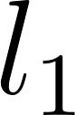, 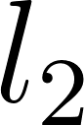 and joint angles 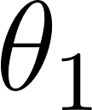, 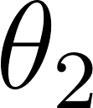 respectively.

// Forward Kinematics for a 2-Link Planar Manipulator
// Inputs: l1, l2 -- link lengths in metres
// theta1 -- joint 1 angle in degrees (measured from X-axis)
// theta2 -- joint 2 angle in degrees (measured relative to link 1)
// Outputs: x, y -- end effector position in metres
// Constant: PI ← 3.14159265
METHOD ForwardKinematics(l1, l2, theta1, theta2)
// Step 1: Convert joint angles from degrees to radians
theta1_rad ← theta1 * (PI / 180)
theta2_rad ← theta2 * (PI / 180)
// Step 2: Calculate the sum of joint angles
// This gives the absolute angle of link 2 relative to the X-axis
theta_sum ← theta1_rad + theta2_rad
// Step 3: Calculate end effector x coordinate
// x = l1*cos(θ1) + l2*cos(θ1 + θ2)
x ← (l1 * COS(theta1_rad)) + (l2 * COS(theta_sum))
// Step 4: Calculate end effector y coordinate
// y = l1*sin(θ1) + l2*sin(θ1 + θ2)
y ← (l1 * SIN(theta1_rad)) + (l2 * SIN(theta_sum))
// Step 5: Return the end effector position vector
PRINT "End Effector Position:"
PRINT "x = " + x
PRINT "y = " + y
RETURN x, y
ENDMETHOD
// --- Main Program ---
READ l1
READ l2
READ theta1
READ theta2
CALL ForwardKinematics(l1, l2, theta1, theta2) RETURNING x, y

Task 3 - Forward Kinematics

Task 3a - Python Script
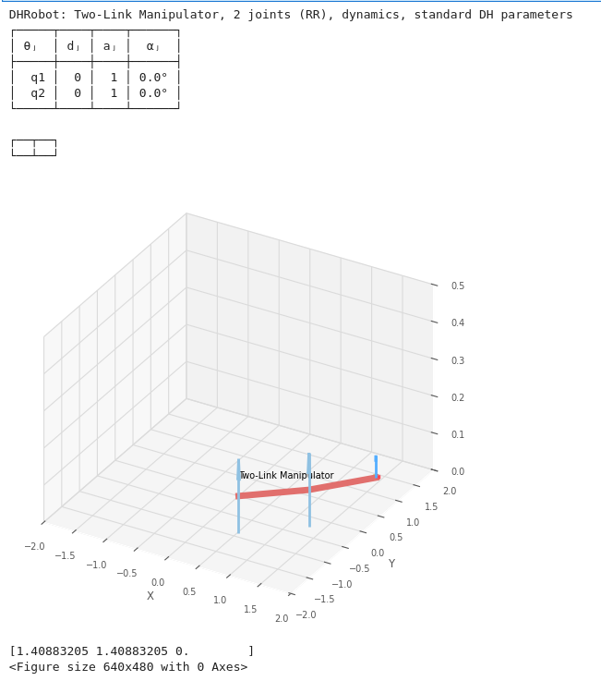
Record the output and compare the results to what you calculated in Task 2a
As seen in the screenshot above, the returned value is the same as the ones calculated in Task 2a, thus validating the calculations performed in that task

Task 3b - DH Parameters

Task 1 - Draw the Link diagram
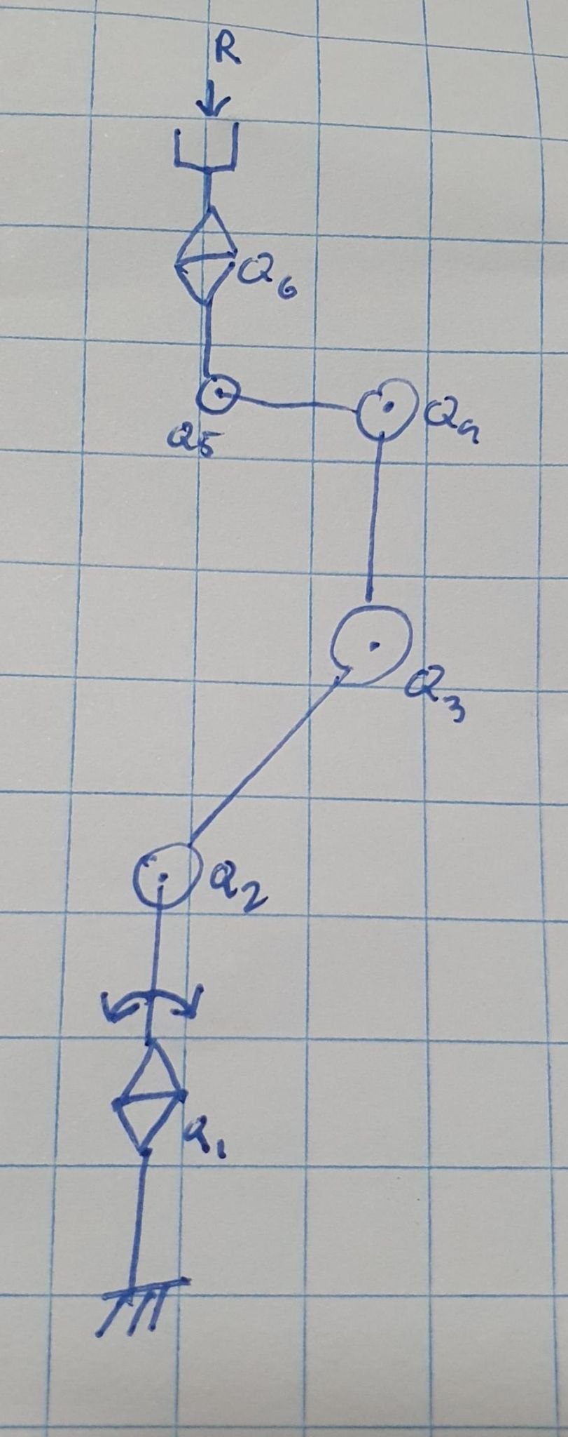

Task 2 - Tabulate the DH parameters
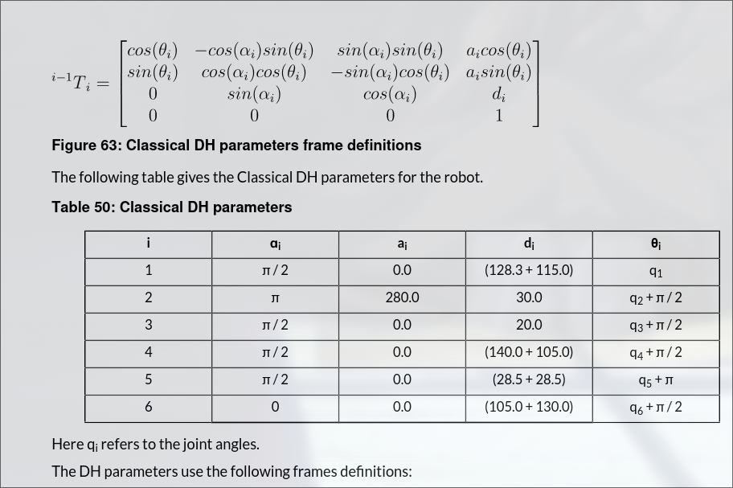
Sourced from the Official Kinova Gen3 lite robot User guide: Page 135

Task 3c - Python Script

Note the joint angles of the robot using the Kinova web interface
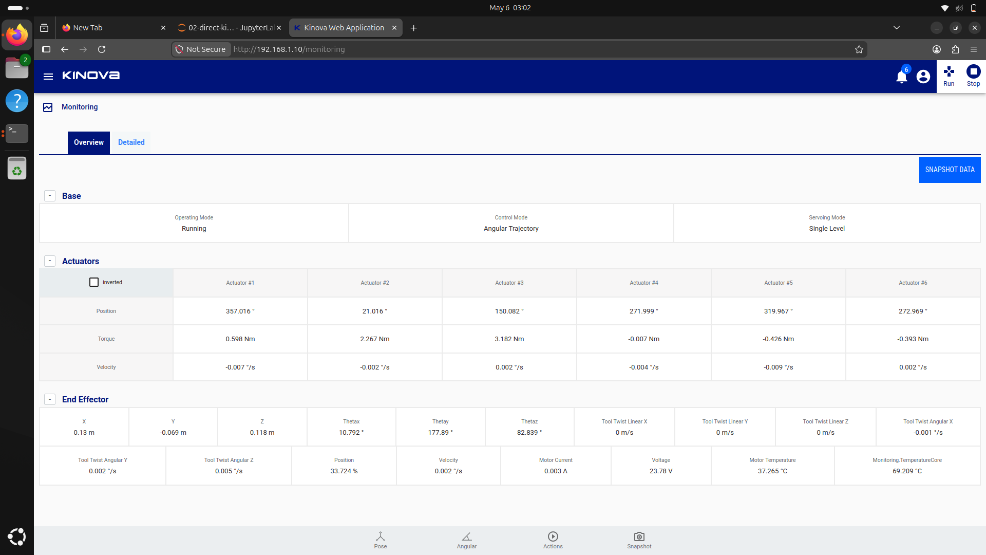

Source code to generate the Kinova robot model using the Robotics Toolbox
import math
import roboticstoolbox as rtb # load the robotics toolbox
# the robot model can be defined using the the robotics toolbox
# The DHRobot object stores the joint information for the robot
# RevoluteDH objects can be used to represent each revolute joint in the robot model
# DH parameters are used to define the robot joint relationships
q = [math.radians(357.016), math.radians(21.016), math.radians(150.082), math.radians(271.999), math.radians(319.967), math.radians(272.969)]
robot_2dof = rtb.DHRobot(
[
# the RevoluteDH class represents a revolute joint using DH parameters
# this is a list of 2 joints representing 2 degrees of freedom (DOF)
rtb.RevoluteDH(
d = (128.3+115.0),
alpha = (math.pi/2),
a = 0, # note that the dimensions are in m instead of mm
offset = 0
),
rtb.RevoluteDH(
d = 30.0,
alpha = (math.pi),
a = 280,
offset = (math.pi/2)
),
rtb.RevoluteDH(
d = 20,
alpha = (math.pi/2),
a = 0, # note that the dimensions are in m instead of mm
offset =(math.pi/2)
),
rtb.RevoluteDH(
d = (140.0+105.0),
alpha = (math.pi/2),
a = 0,
offset =(math.pi/2)
),
rtb.RevoluteDH(
d = (28.5+28.5),
alpha = (math.pi/2),
a = 0, # note that the dimensions are in m instead of mm
offset =math.pi
),
rtb.RevoluteDH(
d = (105.0+130.0),
alpha = 0,
a = 0,
offset =(math.pi/2)
)
],
name = "Six-link"
)
# this will print the robot model details
print(robot_2dof)
# this will plot the robot model graphically
#robot_2dof.plot(q, limits=[-2.0, 2.0, -2.0, 2.0, 0.0, 0.5])
'''
Find the end effector pose given the measured joint angles
'''
# create an array of joint angles
# for example:
#
# joint_angles = np.array([0,0,0,0,0,0])
# plot the robot model
robot_2dof.plot(q, limits=[-500, 500, -500, 500, -500, 500])
# get the end effector pose
pose_2 = robot_2dof.fkine(q)
# print the end effector pose
print(pose_2.t)

Screenshot of the final pose of the robot as generated by the robotics toolbox and output of the command print(pose.t)
